**Doctor Management Application**

**Overview :**

The Doctor Management Application is designed to help users and administrators manage doctor records efficiently. The application provides functionality to add, view, update, and delete doctor information while maintaining a clean and intuitive user interface.

The system is powered by a React.js frontend and an Express.js + MongoDB backend, ensuring a seamless flow of data between the client and server.

**Tech Stack**

Frontend: React.js, CSS

Backend: Node.js, Express.js

Database: MongoDB

**Actors**

Admin/User:

Can add, update, delete, and view doctor information.

**Features**

Admin/User Operations

Add New Doctor

Admin can add doctor records, including:

ID

Name

Specialization

Phone Number

Location

**View Doctor List**

A complete list of doctors is displayed in a table format with columns for:

ID

Name

Specialization

Phone Number

Location

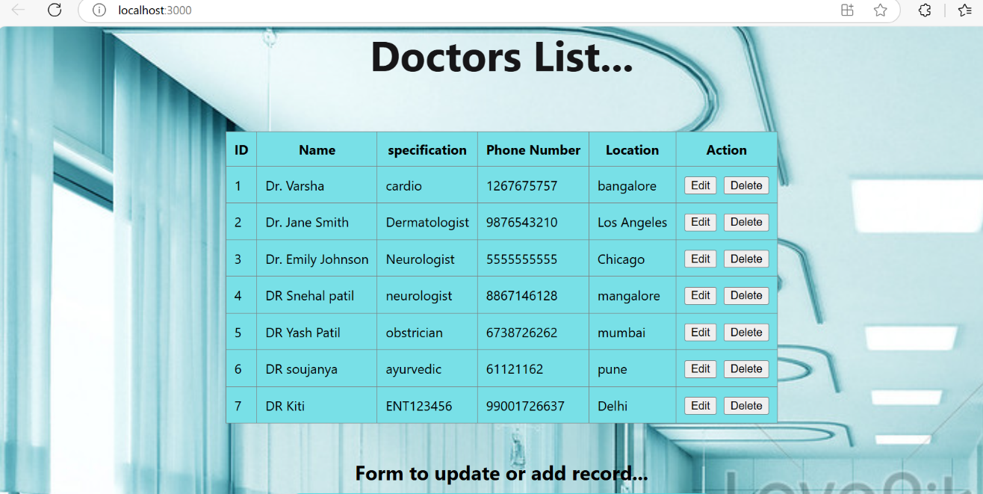

**Update Doctor Information**

Admin can edit and update existing doctor records directly from the table.

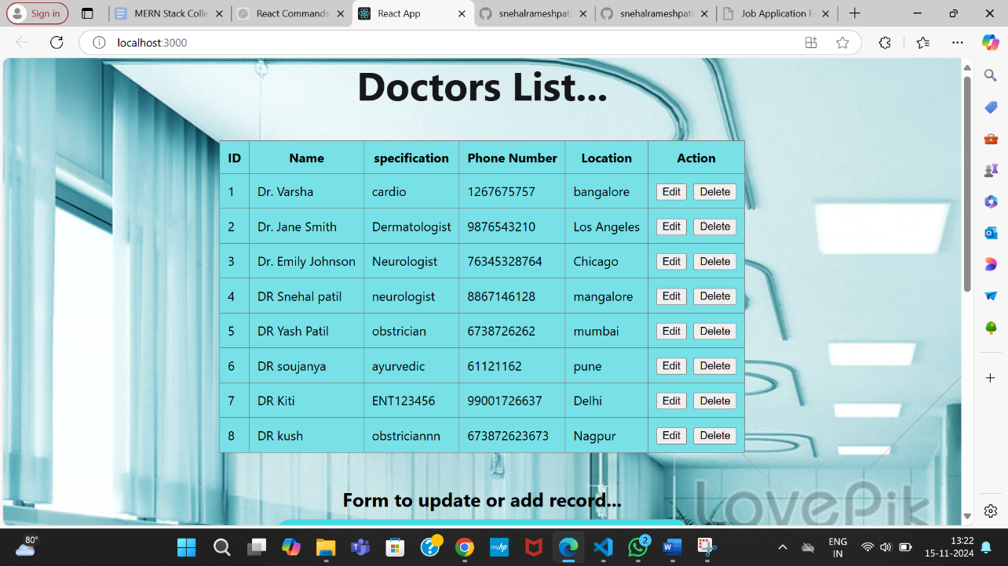

**Delete Doctor Record**

Admin can delete a doctor record from the list.

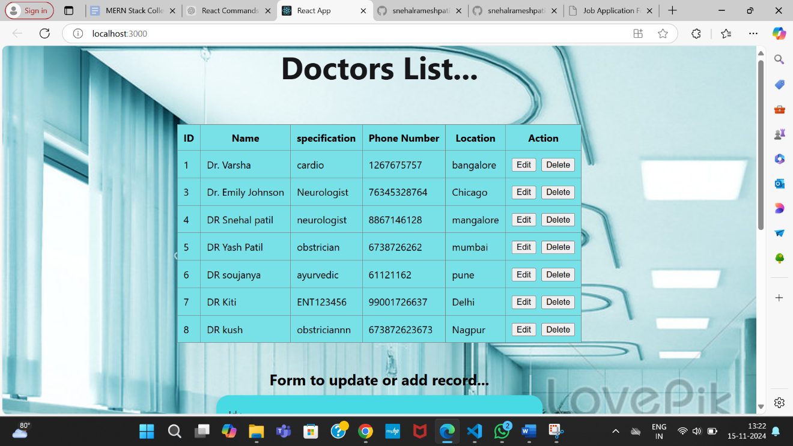

**Search Functionality**

Filter or search doctors based on criteria like ID, Name, or Specialization (future enhancement).

id Number Unique ID of the doctor

name String Doctor's name

specification String Doctor's specialization

phone_num Number Contact number

location String Location or clinic address

Pages

Frontend Pages

**Doctor List Page**

Displays all doctors in a table format.

Includes action buttons: Edit and Delete.

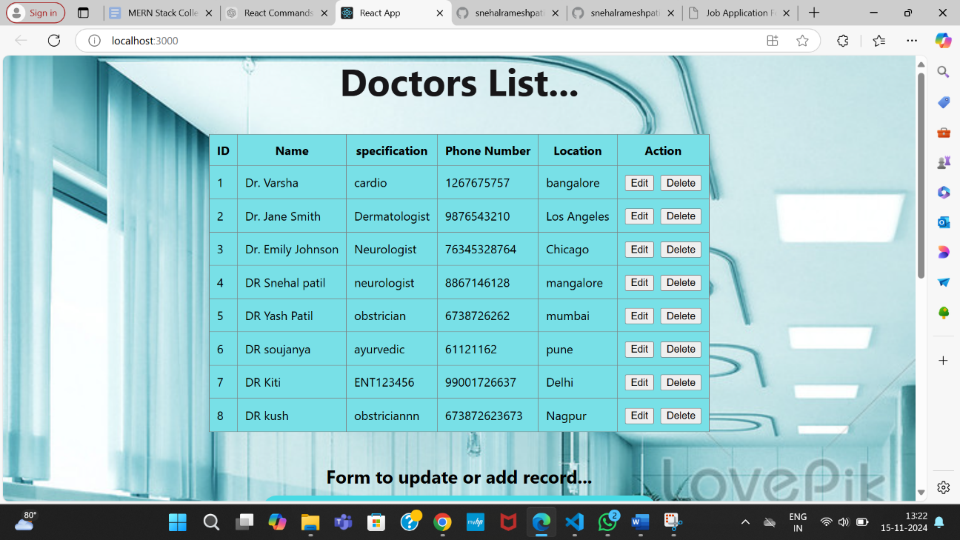

Doctor Form Page

Form to add or update doctor information.

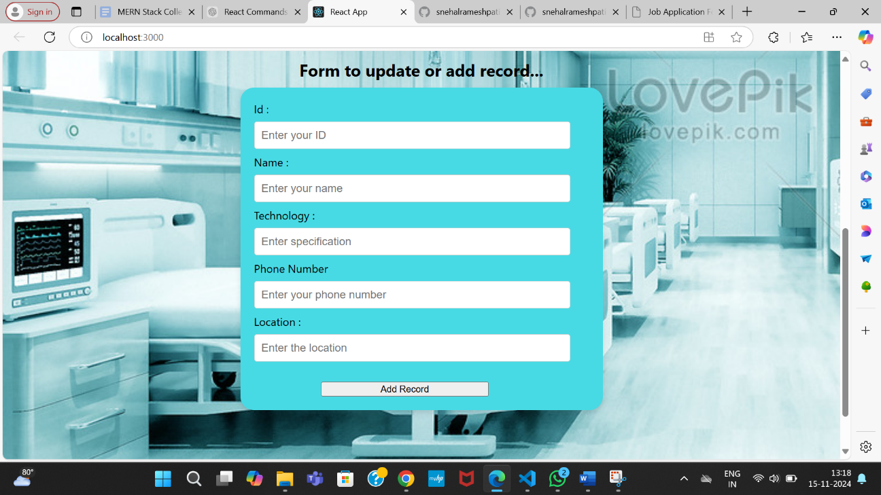

Fields: ID, Name, Specialization, Phone Number, Location.

**Admin/User Functionalities**

Add, update, or delete records using a form-based interface.

API Endpoints

Backend Routes

Method Endpoint Description

POST /adddoctor Add a new doctor

GET /docinfo Fetch the list of all doctors

PUT /updatedoctor/:id Update doctor information by ID

DELETE /deletedoctor/:id Delete doctor information by ID

Doctor List Table

Displays all doctor details with Edit and Delete buttons in the last column.